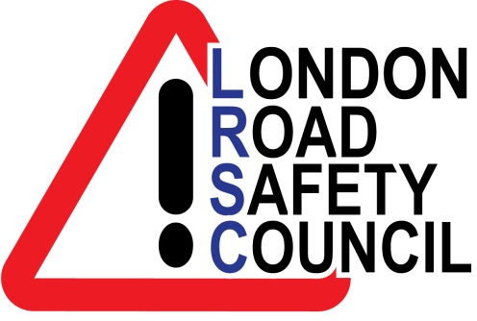
LONDON ROAD SAFETY COUNCIL - SCHOOL KEEP CLEAR RESOURCES
(Spring 2016)
KEYRINGS
500+ | £0.80 EACH
1000+ | £0.75 EACH
1500+ | £0.70 EACH
2000+ | £0.65 EACH
5000+ | £0.45 EACH
10000+ | £0.35 EACH

‘PLEASE DO NOT PARK HERE’ PARKING TICKET DOUBLE- SIDED DL LEAFLET
500+ | £0.12 EACH
2000+ | £0.11 EACH
5000+ | £0.07 EACH
10000+ | £0.05 EACH

PARKING PROMISE DOUBLE- SIDED A5 LEAFLET
500+ | £0.15 EACH
2000+ | £0.11 EACH
5000+ | £0.07 EACH
10000+ | £0.05 EACH

SAFER SCHOOL JOURNEYS 4 PAGE A5 LEAFLET
500+ | £0.24 EACH
2000+ | £0.14 EACH
5000+ | £0.09 EACH
10000+ | £0.07 EACH
You can purchase the above in any combination. For example, you can get 500 keyrings and 2000 Parking Promise leaflets. Please note that you are not obliged to purchase all 4 products.
To have your borough logo featured please add £30 for design costs.
All plus carriage. We do not charge VAT.
Please send your purchase order to admin@londonroadsafetycouncil.org.uk
Or London Road Safety Council, PO Box 669, Addlestone, Surrey KT15 9EB

